**INTRODUCTION**

PROJECT TITLE

**FITFLEX**

**YOUR PERSONAL FITNESS COMPANION**

TEAM MEMBERS:

**D.DIVYA SREE (Code executing , Content creator ,Audio present)**

**B.JAYASRI (video editor ,uploading work)**

**D.DHARSHINI (document creator , alignment editor)**

**B.NISHA (Phase editor , Idea presenter)**

**2. PROJECT OVERVIEW**

* **PROJECT NAME :** Fit flex
* **PROJECT TYPE :** Fitness & Wellness Platform

**PURPOSE :**

**To develop a user-friendly platform that helps individuals archive their fitness goals through personalized workout plans, nutrition guidance ,and progress tracking.**

**FEATURES :**

**Fit flex is designed to help you stay on top of your fitness journey, providing a flexible and supportive framework for achieving your goals.**

**3. ARCHITECTURE**

**COMPONENT STRUCTURE :**

**This component structure provides a solid foundation for building a scalable, secure, and maintain a fit flex system**

**STATE MANAGEMENT:**

**By implementing a well-structured state management system, fit flex can ensure a seamless and predictable user experience**

**ROUTING :**

**Fit Flex is a fitness app that provides personalized workout plans and routing for outdoor activities like running, cycling, and hiking. Here's an overview of the routing feature in Fit Flex**

**4. SETUP INSTRUCTIONS**

**PREREQUISITES :**

**Hardware Requirements :**

**1. Smartphone or Tablet**: Fit Flex is compatible with iOS and Android devices**.**

**2. GPS and Location Services:** Fit Flex requires GPS and location services to track routes and provide location-based features.

**Software Requirements :**

**1. Operating System:** Fit Flex is compatible with iOS 14 or later and Android 10 or later.

**2. Fit Flex App:** Users must download and install the Fit Flex app from the App Store or Google Play Store**.**

**INSTALATION:**

1. **Device Compatibility**: Ensure your device is compatible with Fit Flex (iOS 14 or later, Android 10 or later).

2**. Storage Space**: Ensure you have sufficient storage space on your device (approximately 100 MB).

3**. Internet Connection**: Ensure you have a stable internet connection.

**5. FOLDER STRUCTURE**

**CLIENT:**

1. **MOBILE APPS** : iOS and Android apps for smartphone and tablets.
2. **Web Applications:** A web-based application accessible on desktop and laptop computers.
3. **Wearable Devices:** Integration with popular wearable devices, such as fitness trackers and smart watches

**UTILITIES:**

**1**. **Enhanced User Experience**: Fit Flex Utilities provide a more seamless and personalized experience for users.

2**. Increased Efficiency**: Utilities automate various tasks, streamline processes, and reduce manual effort.

3**. Improved Accuracy**: Utilities provide accurate and reliable data, reducing errors and inconsistencies.

4. **Customization and Flexibility**: Utilities allow users to tailor their FitFlex experience to their specific needs and preferences

**6. RUNNING THE APPLICATION**

1. **User Interactions**: Users interact with the application, creating, reading, updating, and deleting data.

2. **Data Processing**: The application processes user data, performing calculations, and generating reports.

3. **Notification System**: The application sends notifications to users, reminding them of upcoming workouts or providing motivational messages.

**FRONTEND:**

1. **User Interface (UI):** The visual elements and layout of the application, including buttons, forms, and graphics.

2. **User Experience (UX):** The overall experience and interaction of the user with the application, including navigation, responsiveness, and accessibility.

**Technologies Used in Fit Flex Frontend :**

**1. HTML5**: For structuring and organizing content.

**2. CSS3:** For styling and layout

**3. JavaScript:** For client-side logic and dynamic interactions.

**4. Bootstrap:** A front-end framework for responsive design and layout.

**5. Material-UI:** A popular UI library for React application

**7. COMPONENT DOCUMENTATION**

**KEY COMPONENTS:**

1**. Dashboard**: A personalized dashboard for users to track their progress and goals.

**2. Navigation Menu**: A menu that allows users to navigate through different sections of the application.

**3. Workout Logger:** A feature to log and track workouts, including exercises, sets, reps, and weight.

**4. Nutrition Planner:** A feature to plan and track nutrition, including meal planning and grocery lists.

**REUSABLE COMPONENTS:**

**1. Workout Card**: A reusable component that displays a workout summary, including exercise names, sets, reps, and weight.

**2. Nutrition Table**: A reusable component that displays a table of nutrition information, including macronutrients, calories, and meal planning details.

**3. Progress Chart**: A reusable component that displays a chart of user progress, including weight, body fat percentages

**8. STATE MANAGEMANT**

**GLOBAL STATE:**

**In state management, the global state refers to the centralized storage of data that can be accessed and updated by various components or parts of an application.**

* **Shared across multiple components or features**
* **Required for the application's core functionality**
* **Updated in real-time, reflecting changes made by users or other parts of the application**

**LOCAL STATE:**

**In state management, local state refers to the data that is specific to a particular component, feature, or module within an application. This data is typically:**

* Private to the component and not shared with other parts of the application
* Used for rendering the component's UI or handling its specific logic
* Updated independently of the global state, although it may be influenced by it

**9. USER INTERFACE**

**As a fitness management system, Fit Flex's UI plays a crucial role in providing a seamless and engaging experience for users. A well-designed UI can help users navigate the system efficiently, access relevant information, and perform tasks with ease.**

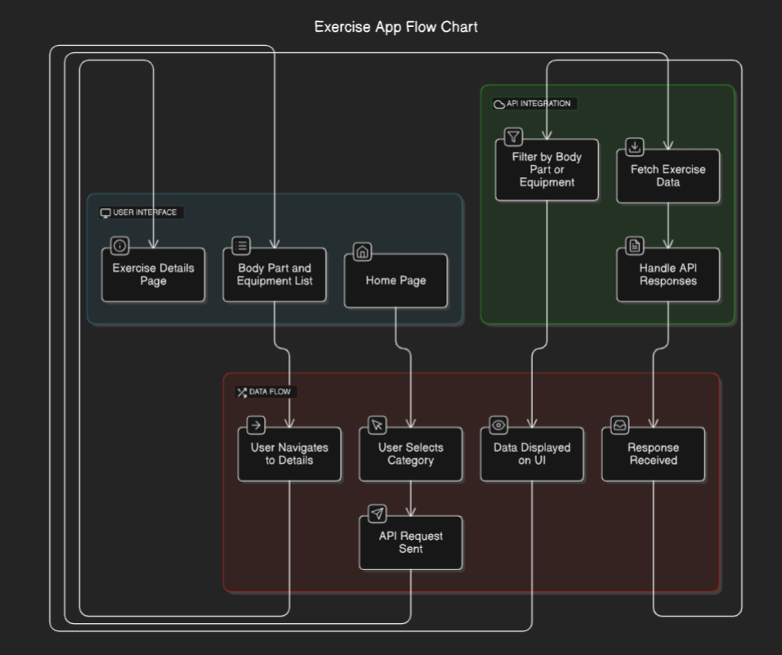

**10. STYLING**

**CSS FRAMEWORKS/LIBRARIE:**

**CSS frameworks and libraries can greatly simplify and accelerate the styling process, providing pre-built components, layouts, and utilities to help you create visually appealing and consistent interfaces.**

* + Learning curve
  + Customizability
  + Community support
  + Browser compatibility
  + Performance

**THEMING:**

**Theming refers to the process of creating a consistent visual identity for a website or application by defining a set of colors, typography, spacing, and other visual elements. This helps to create a cohesive and recognizable brand image.**

**11. TESTING**

**TESTING STRATEGY:**

**A testing strategy is a comprehensive plan that outlines the approach, methods, and techniques to be used for testing a software application or system. It ensures that the testing process is efficient, effective, and aligned with the project's goals and objectives.**

**CODE COVERAGE:**

**Code coverage is a measure of how much of the code base is executed during testing. It's a metric that helps you understand how thoroughly your tests are exercising the code.**

**12. SCREENSHORTS OR DEMO**

**Screenshots and demos are excellent ways to showcase the features and functionality of Fit Flex, a fitness management system. They can help users, stakeholders, or potential customers visualize how the system works and what benefits it offers.**

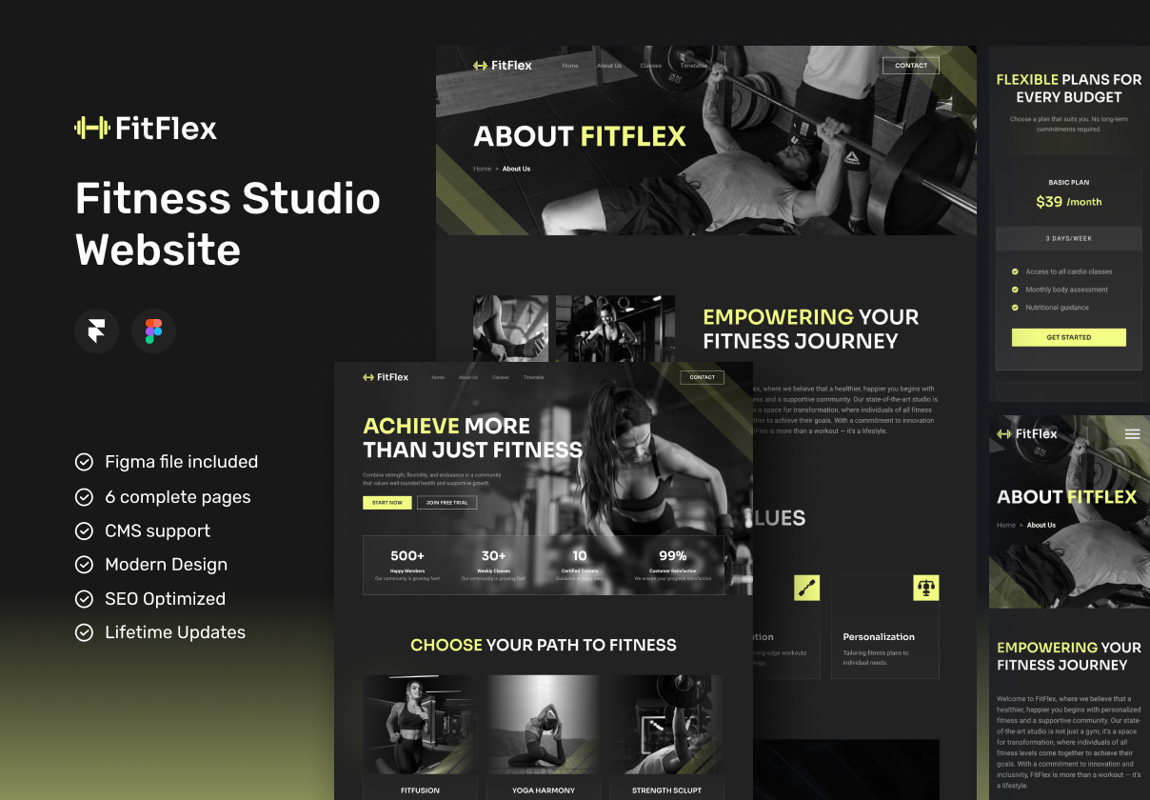

* **UI screenshots: Showcase the user interface, highlighting key features and navigation.**
* **Feature screenshots: Focus on specific features, such as workout planning, tracking, or analytics.**
* **Success story screenshots: Share screenshots of successful implementations, highlighting user achievements or testimonials.**

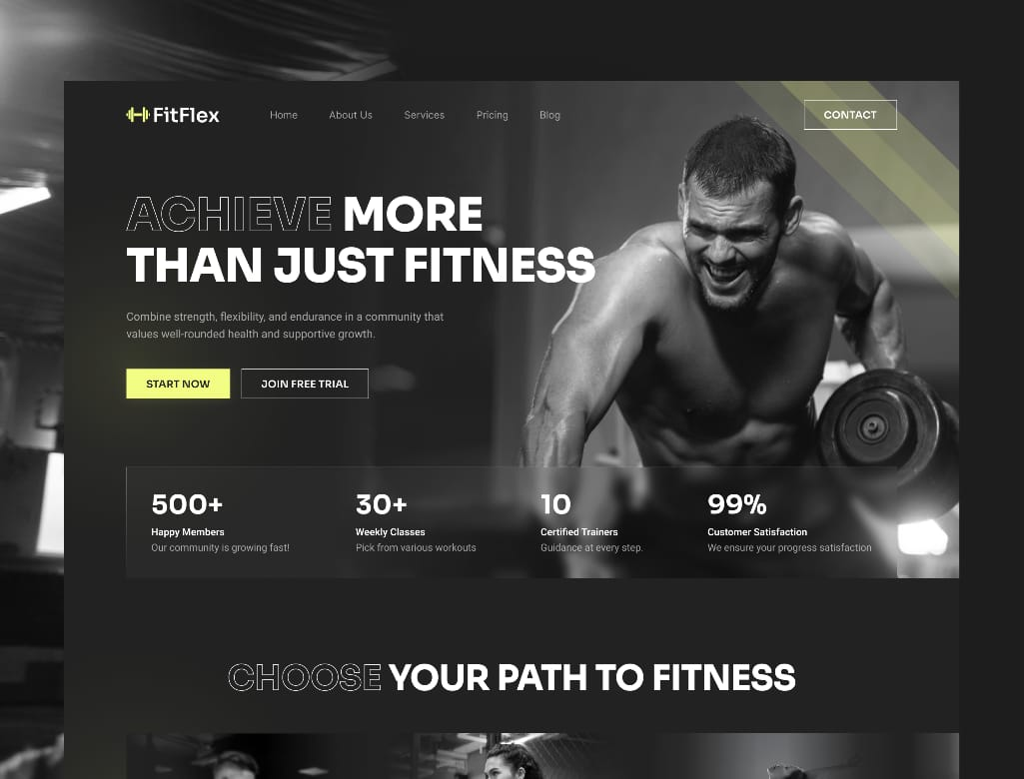

**https://drive.google.com/drive/folders/1mgQpSW8m7EZJu6s4rjl0g47ypIjR3aCN?usp=sharing**

**13. KNOWN ISSUES**

**User Interface Issues**

**1. Navigation and Menu Issues:** Some users may experience difficulties navigating the app or accessing certain features due to menu or navigation issues.

**2. Display and Rendering Issues:** The app may not always display correctly, with issues such as misaligned text, incorrect formatting, or missing graphics.

**3. Accessibility Issues:** The app may not be fully accessible to users with disabilities, with issues such as inadequate screen reader support or insufficient color contrast.

**Platform-Specific Issues**

**1. iOS-Specific Issues**: Some issues may be specific to the iOS platform, such as difficulties with Cloud syncing or issues with Apple Health integration.

**2. Android-Specific Issues**: Some issues may be specific to the Android platform, such as difficulties with Google Fit integration or issues with Android Wear compatibility.

**14. FUTURE ENHANCEMENTS**

**Artificial Intelligence (AI) and Machine Learning (ML) Integrations**

**1. Personalized Workout Recommendations**: Use AI and ML to provide personalized workout recommendations based on user fitness goals, fitness level, and preferences.

**2. Predictive Analytics**: Use AI and ML to predict user progress, identify potential plateaus, and provide recommendations for improvement.

**Virtual and Augmented Reality (VR/AR) Integrations**

**1. Immersive Workout Experiences**: Provide immersive workout experiences using VR/AR technology, including virtual fitness classes and personalized coaching.

**2. Interactive Fitness Games**: Develop interactive fitness games that use VR/AR technology to make workouts more engaging and fun.

**Internet of Things (IoT) Integrations**

**1. Wearable Device Integration**: Integrate with wearable devices, such as smart watches and fitness trackers, to track user activity, sleep, and nutrition.

**2. Smart Home Integration**: Integrate with smart home devices, such as Amazon Alexa and Google Home, to provide users with a seamless fitness experience.